

# MADAM’S BOUTIQUE

**Supervisor:** *NGUYỄN HẠ VY*

**Semester:** *01*

**Batch No:** *T1.2207.E1*

**Group No:** *04*

|  |  |  |
| --- | --- | --- |
| **Order:** | **Full name** | **Roll No.** |
| *1.* | *DIỆP QUỐC QUYỀN* | Student1396952 |
| *2.* | *NGUYỄN DUY KHIÊM* | Student1396945 |
| *3.* | *PHAN HOÀNG PHÚC* | Student1397178 |
| *4.* | *PHẠM ANH TUẤN* | Student1396966 |

***Month****: 10* ***Year****: 2022*



This is to certify that

**Mr. DIỆP QUỐC QUYỀN Mr. NGUYỄN DUY KHIÊM Mr. PHAN HOÀNG PHÚC**

**Mr. PHẠM ANH TUÁN**

Have successfully Designed & Developed

# MADAM’S BOUTIQUE

Submitted by:

**Ms. NGUYEN HA VY**

Date Of Issue:

Authorized Signature:

# Content

Content Acknowledge Synopsis

Review1

Review2

Tasksheet ..(5)

# Acknowledge

As we understand that the eProject is a step-by-step learning environment that closely simulates the classroom and Lab-based learning environment into actual implementation. It is a project implementation at your fingertips!! An electronic, live juncture on the machine that allows you to.

* Practice step by step i.e. laddered approach.
* Build a larger more robust application.
* Usage of certain utilities in applications designed by user.
* Single program to unified code leading to a complete application.
* Learn implementation of concepts in a phased manner.
* Enhance skills and add value.
* Work on real-life projects.
* Give a real-life scenario and help to create applications that are more complicated and useful.
* Mentoring through email support.

First of all, I would like to thank India Aptech for allowing my team to work on this fantastic eProject. We had a great experience with eProject this time.

Next, We would like to express my special thanks to our mentor, Ms. Ha Vy for the time and effort that she provided throughout the project. Your helpful advice and suggestions were beneficial to us during the completion of the project. In this respect, We are forever grateful to you.

Besides several mistakes we made in the project, we hope to have more opportunities to widen our knowledge in the web-developing world.

We will try to continue to learn and improve ourselves even more in the future.

Yours Sincerely, Team Group 04.

# Synopsis

The Objective of this program we aim is to give a sample project to work on real- life projects. These applications help us build a larger more robust application.

The objective is not to teach us HTML/JavaScript but to provide us with a real-life scenario and help us create basic applications using the tools.

Hence, we can revise the chapters before we start with the project.

This project is meant for students like us who have completed the module of HTML5. These programs should be done in the Lab sessions with the assistance of the faculty if required.

The website (in this project) is a tool that brings everything in the world to you such as historic monuments information natural knowledge and skill in technology...

It is very essential for us that will have a clear understanding of the subject. We think we should go through the project and solve the assignments as per the requirements given.

And get back [***eprojects@aptech.ac.in***](mailto:eprojects@aptech.ac.in) as the assigned schedule.

## Problem Definition

**Madam’s Boutique** is the leading store of branded and designer clothes for women.

The boutique has tie up with various designers whose collection is on their display.

Also different apparel, accessories collection is also available with the store. The

website must be designed for this boutique showing the collection of clothing of

various brands, designer, unstitched garments. A website needs to be developing for

the boutique which must display all the collection.

The website is to be developed for the Windows Platform using HTML5, JavaScript

and Geolocation. The site should work well in all leading browsers including Chrome,

IE, Firefox etc.

Requirement Specification:

The Web site is to be created based on the following requirements.

1) The Home Page should be created making use of sections with a suitable

logo.

2) Collection must be made more categorized as per the designers and types of

attire.

3) Color combination must be made more précised in the application so that

clothes must be properly highlighted.

4) Navigation needs to be smoother.

5) Comparison of different brands must be included in the website.

6) Gallery section of the boutique’s hit collection must be included.

7) The look and feel of the project must be made user friendly and uniformity in

the color combination must be maintained.

8) About us, Contact Us (address and map) must be added. Address of the

Company should be displayed using GeoLocation API (eg. GoogleMaps).

9) Images must be added with its alt attribute defined.

## Customer Requirements Specifications

### User:

#### input:

* Information on search.
* Data of registered members.
* Feedback to the webmaster.

#### Process:

* Find the searching
* Check the data of registered members.
* Check the feedback of users.

#### Output:

* Result of searching.
* Confirm the data of registered members.
* Confirm the feedback of the users.

### Hardware/ software requirement:

#### Software:

* + Notepad/HTML editor
  + Dreamweaver
  + IE 5.0/ Netscape 6.0

#### Hardware:

* + A minimum computer system that will help you access all the tools in the courses is a Pentium 166 or better
  + 64 Megabytes of RAM or better

|  |  |
| --- | --- |
| **Document Name**:  Architecture and design of the project | **SWD/Form** No.03/ARD/Ver1.0 |
| **Version** 1.0 | **Page 3** |

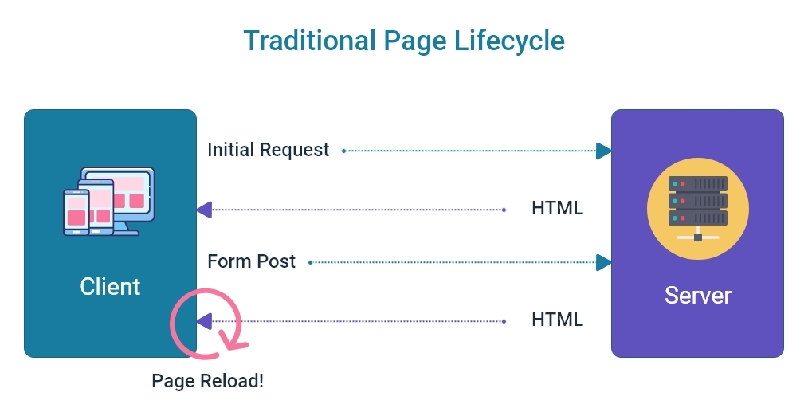

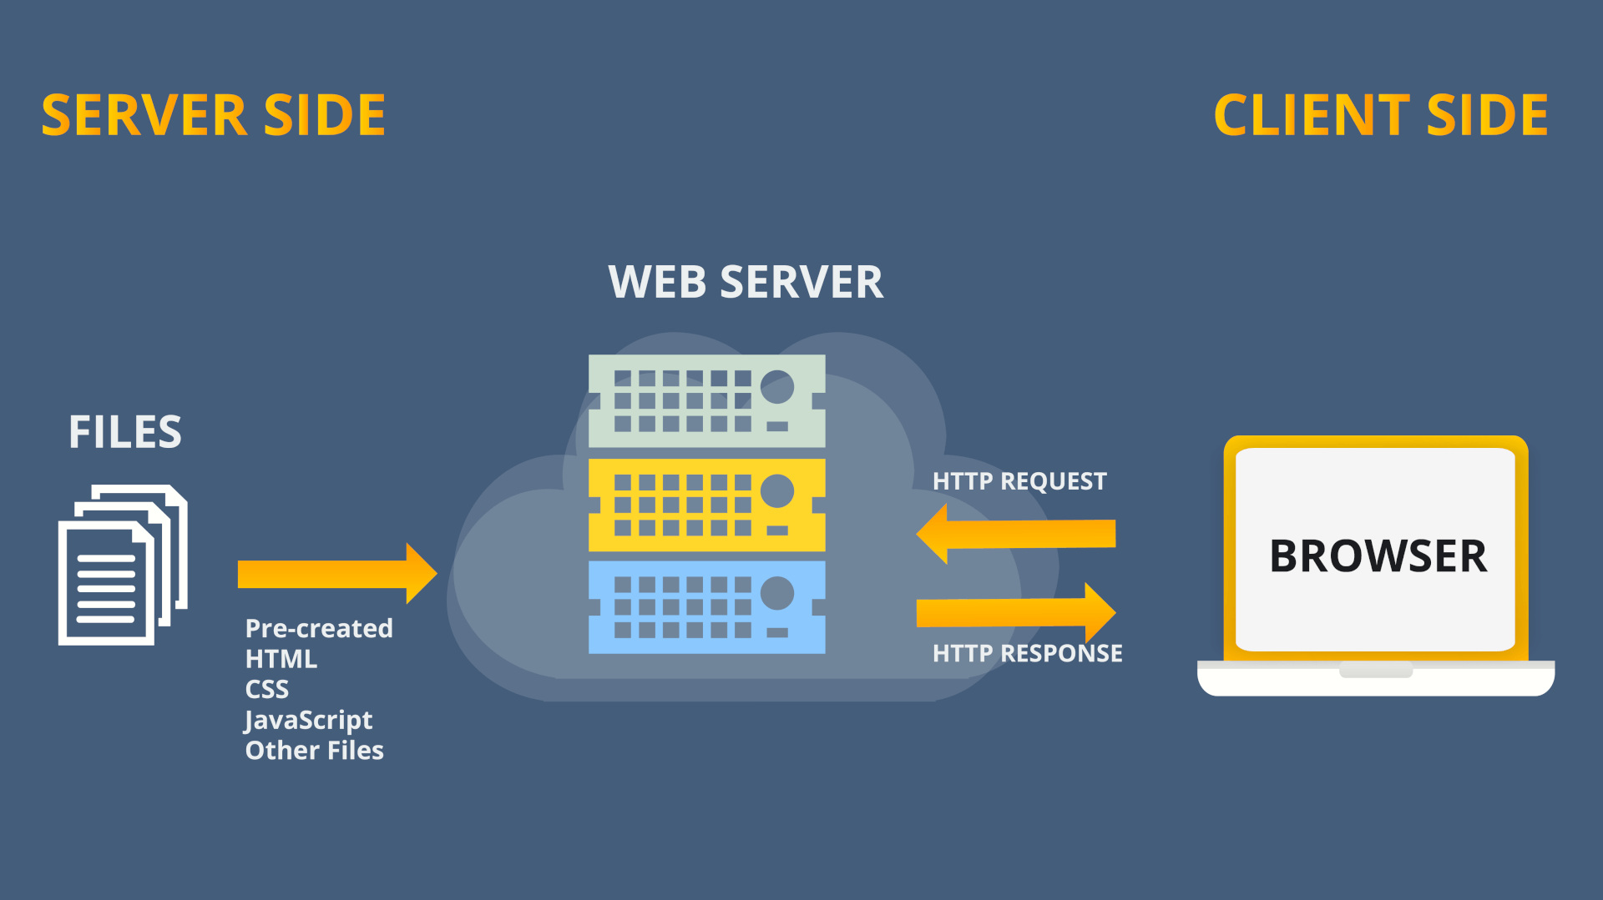

Home

Register/Login

Contact

About us

Categories

Login

Register

Feedback

Business Info

Product Details

Compare product

Add to cart/View

|  |  |  |  |  |  |  |  |
| --- | --- | --- | --- | --- | --- | --- | --- |
| No | Member | Contents | Page Name | Activity Plan | Date of Preparation of Activity Plan | | |
| Planed Start Date | Actual Start Date | Actual Days | Status |
|  | Diệp Quốc Quyền | Home page | index.html | 8/10/2022 | 9/10/2022 | 1 | 100% |
| Categories | categories.html | 11/10/2022 | 12/10/2022 |  | 30% |
|  | Nguyên Duy Khiêm | Categories | categories.html | 11/10/2022 | 12/10/2022 |  | 30% |
| Login/Register | register.html | 11/10/2022 | 12/10/2022 |  | 30% |
|  | Phan Hoàng Phúc | About Us | aboutUs.html | 11/10/2022 | 12/10/2022 |  | 30% |
| Business Info | businessInfo.html | 11/10/2022 | 12/10/2022 |  | 30% |
|  | Phạm Anh Tuấn | Contact Us | contactUs.html | 11/10/2022 | 12/10/2022 |  | 30% |
| Feedback | feedback.html | 11/10/2022 | 12/10/2022 |  | 30% |